|  |  |
| --- | --- |
| *Pacific Gas and Electric Company* | |
| Settings 0.1 Installation Guide | |
|  |  |
|  |  |
| Project | ED AM/GIS – TLM Application Deployment |
|  |  |
| Prepared by | Hitesh Chaudhari |
| Date | 6/4/2014 |
| Version | 0.1 |
| Version Type | Draft |

|  |  |  |  |
| --- | --- | --- | --- |
| Revision History | | | |
| Document # | Date | Author | Summary of Changes |
| 0.1 | 6/2/14 | Hitesh Chaudhari | Initial Document Creation |

# Introduction

## Purpose

This document is intended to detail the implementation and configuration steps required to implement the TLM Application. This document describes the various configuration aspects required to complete the application installation steps for this release.

## Terms Used

|  |  |
| --- | --- |
| OOTB | Out of the box. Unmodified from the commercial version. |
| TFS | Team Foundation Server |
| DB | Database |
| IIS | Internet Information Services |
|  |  |

## External Documents

Referenced are any external configuration documents or exports. These are documents that contain more detailed information about configuring a system or documents that can be loaded into an application to perform the configuration detailed in this document.

## List Of Fixes

Below is the list of change requests detailing all fixes for this release:

|  |  |  |
| --- | --- | --- |
| **Item Number** | **Title** | **Work Item Type** |
|  |  |  |
|  |  |  |
|  |  |  |

## Summary of Steps to Complete Installation

These are the high-level steps to complete the installation and configuration of the TLM Management application. Use this table as a guide for completing the installation. Links are provided that can lead either within the document for detailed explanations or to external sites such as Sharepoint.

|  |  |  |  |
| --- | --- | --- | --- |
|  | **Step Name** | **Description** | **CR (if applicable)** |
|  | IIS Configuration | Configure the Internet Information Services in the web server. | - |
|  | Solution Deployment | Copy the solution files to website. |  |

# IIS (Internet information services) Configuration

1. Create App Pool.
   1. 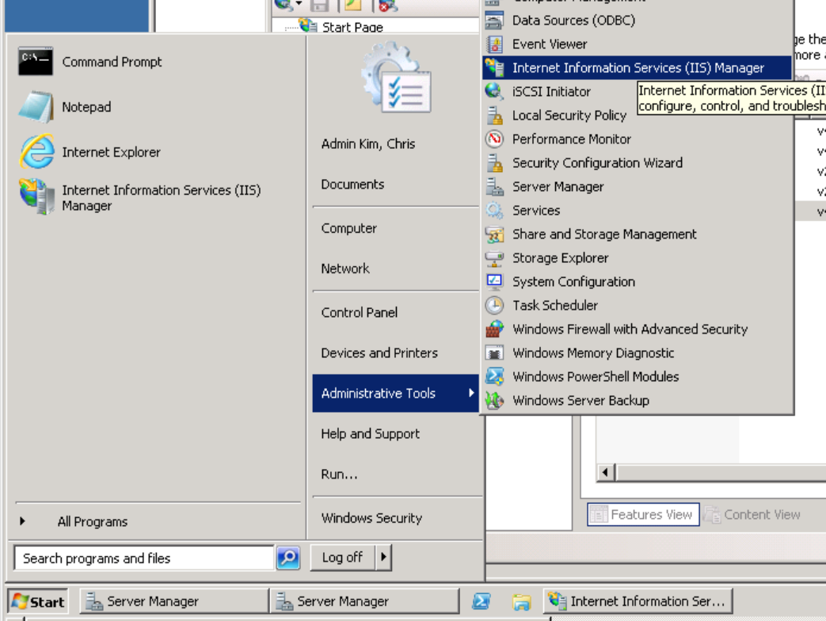Go to start, then administrative tools/Internet information services (IIS) Manager
   2. Expand the server name on the left hand side, then right click on the “Application Pool”, then select the “Add Application Pool”
   3. Put “TLM” as the application pool name and select the .NET Framework version 4.0.30319.

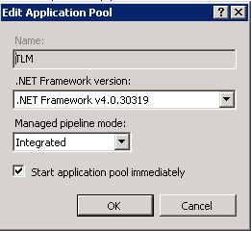

* 1. Once the app pool is created, select the “TLM” in the mid section of the window, and then click on the “Advanced Settings” on the right.

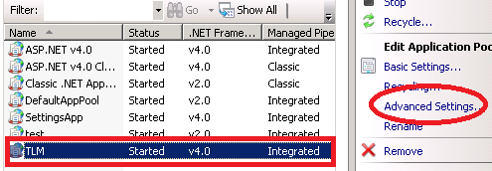

* 1. Click next to “Identity” to open the identity selection window. Select “Custom account” and then click on the Set for the “Custom Account” and put user name as “SVC_ED_TLMApp” and provide the password “”.

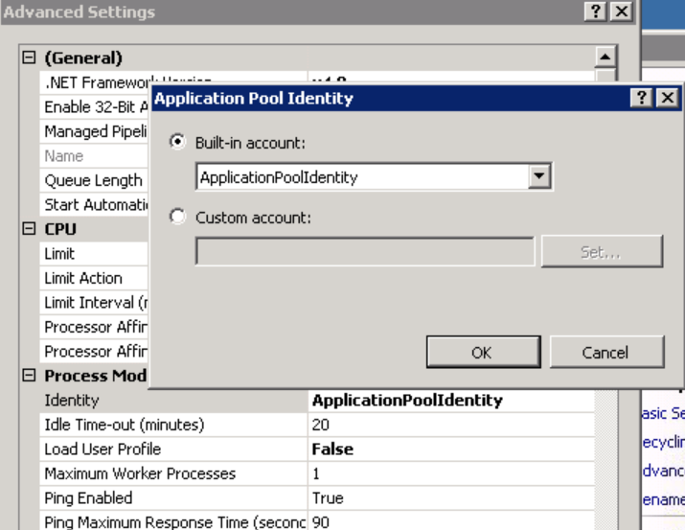

1. Create a website as follows,
2. Expand the the server and right click on the “Site” and select “Add Web Site”

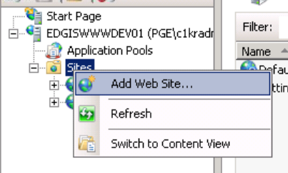

1. Set the attributes listed below:

Site name: “TLM”

Application Pool: “TLM”

Physical path: “D:\inetpub\TLM”

Type: http

IP Address: “All Unassigned”

Port: 81

Host name: “”

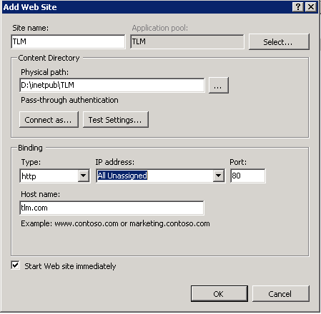

1. Double click on the “Authentication” under IIS section

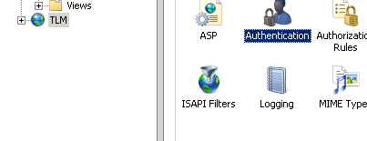

1. Configure it as following:

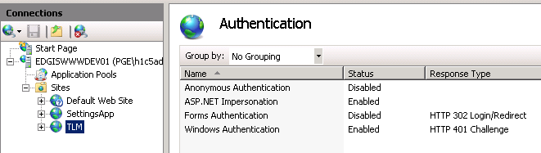

# Deployment of Application

1. Navigate to \\sfetgis-nas01\sfgispoc_data\ApplicationDevelopment\IBM_Delivery\Settings\TLM.
2. Find the approporiate environment, dev, test, stage, prod deployment folder.

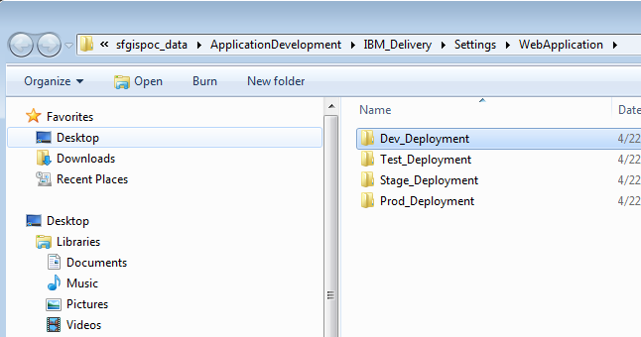

1. Copy the files from the deployment folder to “D:\inetpub\TLM” location on the server.

# Known Issues

<Please List any other issues encountered here while following the document>